Reference Doc - How to call the Backend
Read this document to learn how to make calls to the backend to fetch data or made edits to data
This is a living document that will be updated as new endpoints are made.

Step 1, Login:
First ensure that you are logged in with valid credentials. You will have to have passed through a login page. You can use these sample credentials to log in:
- Username: [add credentials]
- Password: [add credentials]

Step 2, Create code to make API call:
Next, in your code file (whether that be a .tsx, .js, or .ts file) where you want to make the API call occur, you will want to import this at the top of the file:
import { fetchAuthSession } from 'aws-amplify/auth'

You will then want to make a function to call the particular backend endpoint you want to make a request to.
Here is a basic pattern that works for a GET request. But feel free to develop a better pattern if you find it to be more efficient.
You may get the red underline, but it is simply saying that the value may be undefined. Particularly in the case the user is not logged in. This should not generally be an issue, but it may be worth creating some error handling if your code is reached and the user is not logged in for some reason.
Now you can call this function and get a set of JSON data returned! You will want to print this data somewhere if you want to test if the call was successful or not.
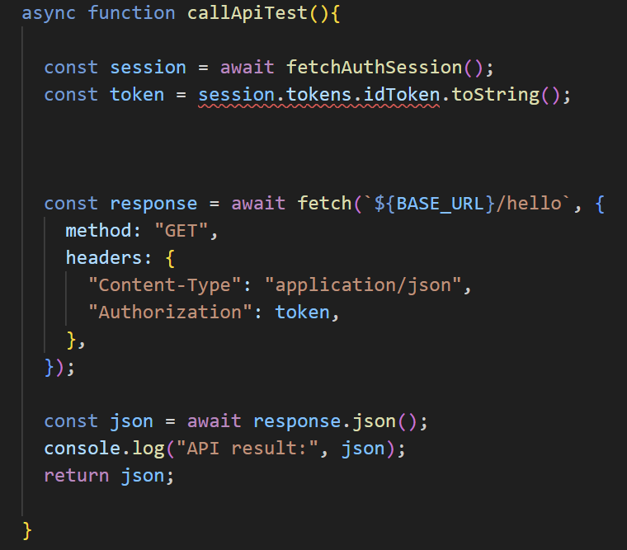
This particular example calls the /hello endpoint. All endpoints that are developed will be documented in the bottom section of this document, check them out!
Also, to get the status code (ie.200, 400, etc.) you can do response.status. This may come in handy

Fun fact:
- In the above picture, notice the const session=…. And const token =.... Lines. These lines extract the JWT token obtained after logging in. Whenever you make an API call you will need to pass this token in.

Step 3, Define the Base URL:
In the above image, you probably noticed that the URL being called is `${BASE_URL}/hello`

You must use this particular type of quote mark or else it won’t work: `

You will also need to define a constant with the base url. I recommend simply placing the base URL in a separate file and have all files that need to make an API call simply import this BASE_URL value, as all endpoints will have the same BASE_URL, and if the BASE_URL ever needs to change you can simply change it in that one central area and the code everywhere will continue as normal.

For now at least, I ask that you do not upload the base url onto our github. Although in theory it should be protected with auth, and is technically not a private url anyhow. I do ask that you don’t upload it as we may be messing with permissions throughout development.
For now you can make a file that is gitignored and place the base url there and import it throughout your code from that file.

This is the Base URL:
[INSERT URL ONCE GENERATED. Can be found on AWS Gateway page]

Extra Notes:
The above image showcases a GET request; no real input parameters are required in those cases other than the authorization and the content-type. Many endpoints are POST however, and require an input. This is what that looks like. In this case the endpoint requires a Template_ID input. Take care to ensure that your inputs have correct capitalization. From testing, Template_id won’t work for example, it must be Template_ID:
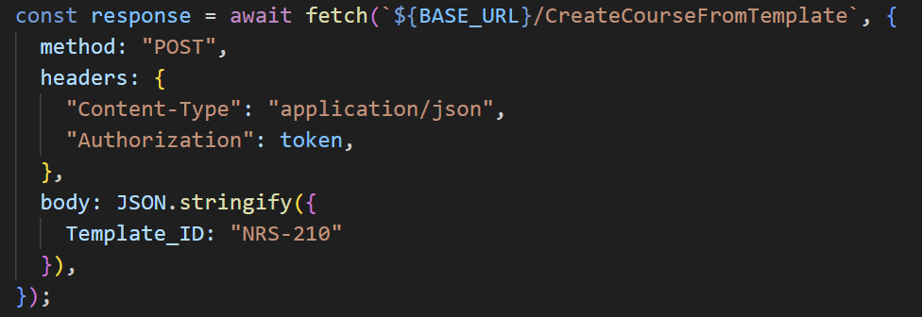
In some other cases you may need to do a GET request that has a list/array as a query parameter in the URL. Here is one way you can do that. In this case we are passing query parameter Student_Emails two emails, test100100@test100100abcdefghi123.com and TestStudent2@SkillTrackIscool.com
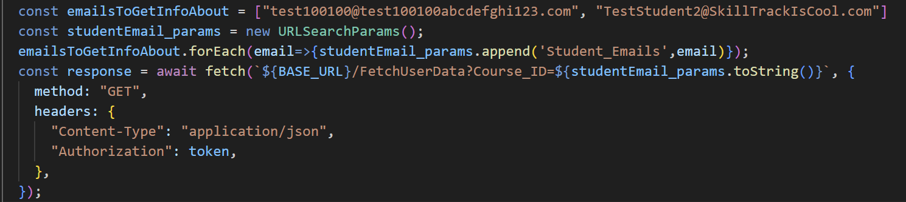

Note: “class” and “course” are used interchangeably

Currently Live Backend Endpoints
Endpoint | Explanation | Remarks
GET {BaseURL}/FetchUserData | This endpoint returns the data of a logged in user. For a student for example, you will see their first and last name, the classes they are enrolled in, and which skills have an have not been checked off.  For a teacher, you will see which classes they are a teacher for, the Class ID’s in specific. Which may be useful for running /GetCourseInformation to get more details on the course, and then using those details to check students off or adding new students off using other endpoints  No inputs are required. But as a teacher you may add an optional query parameter Student_Emails, a list of student emails, which will make the function return student data instead of your data. You can use this to view ALL of a student’s enrollment and skill data. See the image to the right for an example on how to make an API call with a list as a query parameter. | Status Codes:  - 200: Successfully obtained user data  - 201: Successfully created row of dummy data for student and returned then(when planned changes go into place this status code will be removed)  - 500: User data not found. If this is a new account this is normal, and you should move forward with populating a user row. If this is not a new account, something is wrong.  
GET /GetListOfTemplates | This endpoint can be called by a teacher or an admin, and will allow them to view all the templates available as a json. This is purely for informational purposes as templates don’t actually house students or anything  The most important returned value returned will be the ID of each template, as you can use this value to call and pass into /CreateCourseFromTemplate to make a course from that template  *Note The ID of the template may be returned in a format that look something like this: COURSE_TEMPLATE#NRS-210, you ONLY want the part after the # if you call /CreateCourseFromTemplate, so you will want to strip the front part off and just pass in NRS-210
POST /CreateCourseFromTemplate | This endpoint takes a pre-made class template and converts it into an actual teachable course. The calling user is assigned as the teacher for this course. Only a Teacher and and Admin can run this command  See Appendix A for some information on what happens behind the hood  REQUIRED INPUTS  - Template_ID: ID of a template that you want to use to make into course | Status Codes:  - 403: you do not have permission to make a course from a template  - Only teachers and admins can make courses  - 400: The body of your request is formatted incorrectly  - Perhaps you forgot to include the Template_ID parameter in the request body?  - 404: Template ID not found  - 409: Course with this ID already exists  - Due to a current flaw in the code only one course per template can be made in a calendar year. Fix should not be difficult but WIP still. But keep that in mind if you are getting 409s when you try to make multiple courses with the same template  - 200: successfully added student to course
POST  /CreateTemplate | Use this endpoint to create a fresh new course template.  You can pass in the same ID as an already existing template if you want. This will overwrite the previous template with the details you provide here.  REQUIRED INPUTS  - ID: ID of the template. Generally you want this to be in the format of a class code, ie. NRS-210.  - Name: Provide a string name for the course. Ie. NRS 210: Health Promotions  OPTIONAL INPUTS  - Skills: A list(array) each item contains two, values a Name and a Description, it looks like so: Skills: [{"Name": "itemA", "Description": "itemA"}, {"Name": "itemB", "Description": "itemB"}]  - Each skill name MUST be unique. Descriptions do not have to be unique.  - You may leave this empty if you would like to create a template with no skills in it. | Sample JS call:  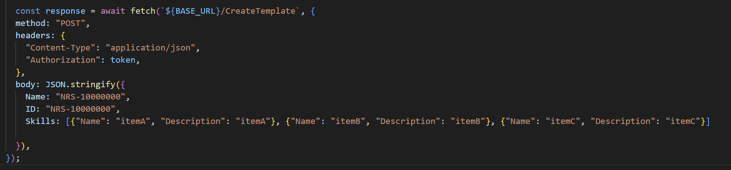
POST  /EditTemplate  DEFUNCT. Endpoint marked for deletion | Use this to edit a pre-existing template. Note that it may be a good idea to ask the user if they want to instead create a new template, if it would be useful to archive this one for example.  Required Inputs:  - TemplateID: ie. NRS-210. Do not include the COURSE_TEMPLATE# prefix in this.  All other inputs are Optional and depend on the modification we want to make.  To make editing actions your json body should have an input called Actions. Which itself houses a list of items to do actions with, so it will look like this  Actions: [{“Action”: “LoremIpsum”  , “Target”: “LoremIpsum”, “Content”: “LoremIpsum”}, {repat of previous element in list}, …etc]  You will need to craft the query based on the particular desired actions. Here is a guide as to the different actions and how they work:  #1 DELETE A SKILL  Action = “deleteSkill”  Target = name of skill to be deleted  Content = N/A  #2 ADD A SKILL  Action = “addSkill”  Target = name of skill you want to add  Content = description of skill you want to add  #3 EDIT SKILL NAME  Action = “editSkillName”  Target = current name of the skill which has a name to be changed  Content = new name of skill  #4 EDIT SKILL DESCRIPTION  Action = “editSkillDescription”  Target = name of skill for which we want to modify its description  Content = new description.  —--------------------------------  To be added -> change template course name and ID  Note that in this case all inputs are optional, it just depends on what type of modification want to be made  Your JSON input should be | Example of the endpoint being called:  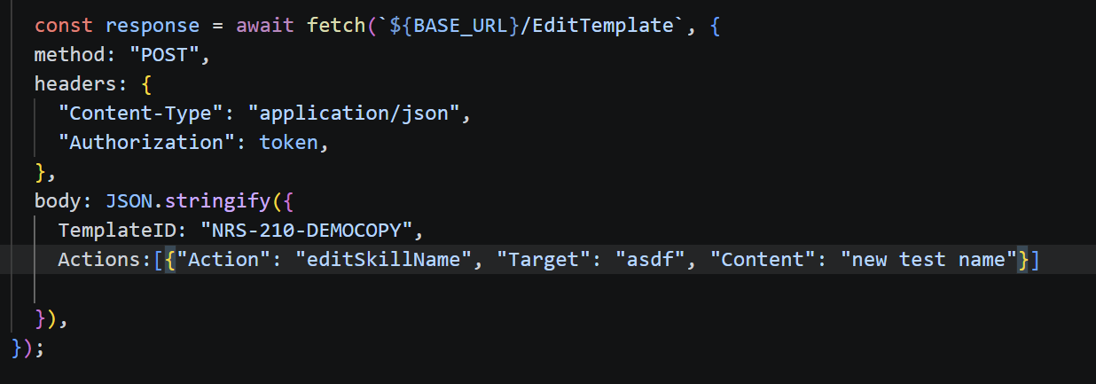  In this particular case for example we can observe that we are editing the NRS-210-DEMOCOPY template and we are changing the name of a skill called asdf into a new name called new test name. Remember, you can specify more than one action, as you submit it as a list, even though this particular example only has one action.
DELETE  /HardDeleteCourse | WARNING: this is a FULL wipe of a course, meaning any record of its existence will be wiped from the database completely; This cannot be undone. The use cases for this endpoint are limited, but the main one is if a course is accidentally created, or made with a mistake right at the start. So it needs to be deleted. Only an admin can call this endpoint  A course that has already started, and has students associated with it, should generally not have this endpoint called  Only an admin can call this endpoint  This call format is very similar to a GET request. It is URL based. There is a single required query parameter called Course_ID. This is the course ID (no COURSE# prefix required) that you want to permanently delete
POST  /CreateUser | This is an admin only call that is used to make new user.  You will input a NewUsers list each item in that list must contain a Email, Password, FirstName and LastName  For example:  NewUsers:[{"Email": "stahlkee@oregonstate.edu", "Password": "asdf267463t4r", "Role": "Student", "FirstName": "Elizabeth", "LastName": "Stahlke"}]  For just one user, but if you want to add users in bulk, simply add another {} entry with all the required fields.  Note that the password must fit certain requirements, it has to be at least 8 long and contain some number or special character | Example of the call  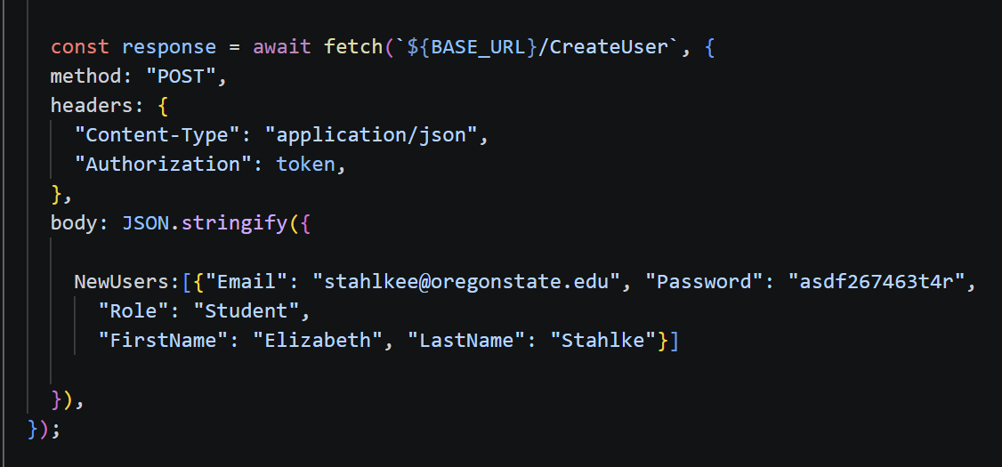  This call would create a account with the email stahlkee@oregonstate.edu, the provided password, and with the name Elizabeth Stahlke. The account would also have the role Student
POST /AddStudentToCourse | When you have a course made, you can add students to it! The fun part is that once you add a student to a class is they will be able to run /FetchUserData and see all the skills listed on their account now!  See appendix B for some info on how this works behind the hood.  Users with the admin role can add a student to any course.  Users with the teacher role can only add students to a course they teach  REQUIRED INPUTS  - Course_ID: ID of the course you want to add students too. For a teacher this will be one of the values in in their TeachingTheseCourses column. Ie. NRS-210-2026  - Student_ID: Student email, ie. “Antonio.Rodriguez@ohsu.com” | - 400: incorrect format  - 403: Do not have correct permission s  - 200: Success  - 500: Generic other error
GET /GetCourseInformation | Use this endpoint to get details on a particular course such as what skills are available for that course, what students are enrolled in this course, what skills those students have completed(read onwards for how to get this information), description for each skill, etc! This endpoint may be useful to get the information necessary to call /CheckStudentOff  This endpoint uses Query parameters for inputs, so for example to input a Course_ID you would use this:  /GetCourseInformation?Course_ID=NRS-210-2026:  If you don’t have the course ID handy for a particular teacher, you can easily obtain the IDs of what courses a teacher teaches with the earlier endpoint /FetchUserInfo, which will include a field showing the IDs of all the courses a teacher is teaching.  Students can call this endpoint too, the only difference being that the student roster will be omitted.  IMPORTANT: This endpoint is purposefully designed to be flexible. Meaning you can use it such that only returns the skills progress for a single student, or that of all students in a course, or a particular selection, or none at all. Please be mindful of what is needed.  Fetching skill progress for all students is more computationally stressful but there are certainly use cases where you might need all this data and this is a preferable to looping this call once for every student (which would be much worse)  INPUTS (Query parameters):  - Course_ID:(REQUIRED) ID of a course ie “NRS-210-2026”  - Student_Emails: (OPTIONAL) A list of student emails that you want to obtain extended information. You will obtain their names, skills (for this course only) and said skills checkoff state. If you only need one student’s info, simply enter the list with only that one email  - GetAllStudentsExtendedSkillInformation(use only when necessary): (OPTIONAL) Submit this query parameter with the string “True” and you will obtain the detailed skill information for ALL students enrolled in the particular course. If Student_Emails is also present this parameter will be ignored.  Excluding the optional inputs will simply not return specific student information. You will still see the student emails enrolled in the course though. The two optional inputs are also only valid for instructors/admins. They will do nothing if a student calls it | If your call requests extended student skill information, the JSON will return it in the StudentsExtended field  Example call with Student_Emails:  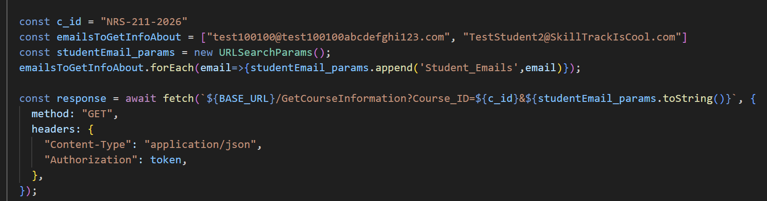  Example call with GetAllStudentsExtendedSkillInformation:  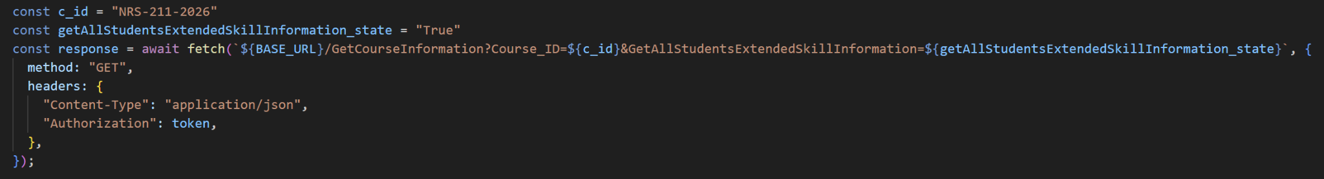  Example call
POST /CheckStudentOff | Check off a student for their skill. An Admin can check off any student for any skill. A Teacher can only check off students for a class they are teaching  REQUIRED INPUTS:  - Course_ID: ID of a course ie “NRS-210-2026”  - Skill_Name: ie. “Handwashing - Infection Prevention”  - Student_List: List of students to check of (you can check of multiple students in one go)  - For example: [“elizabeth100100@ohsu.com”, “Ben.Epic@oshu.com”, “MisterRuss@ohsu.com”]  - Or if you just want to check off one studen, just submit a list with one email: [“elizabeth100100@ohsu.com”]
POST  /FetchUserToken | No extra inputs required. Generates a token that represents a user's email. Use /TokenToEmail to convert the token back to email format.  This is mostly used for the QR code implementation.
GET  /TokenToEmail | REQUIRED INPUTS:  - Token: A randomized token to be translated into an email  This endpoint a Query parameters for input, so for example to input Token your call will look like this:  /GetCourseInformation?Token=abce36547sdfj2hj
POST  /AddDrugCardToUser | Note - If you provide no ID, the endpoint will automatically generate one. If you do provide an ID, the call will fully overwrite the drug card info based on what you submit on this instance.  In that sense this endpoint serves the dual purpose of both allowing you to add new student cards as well as modify already existing ones.  *all inputs are optional, and you could submit literally nothing to create an empty drug card  INPUTS  - CardID - (integer value can be anything. Use a preexisting CardID to overwrite the content of that ID) The /GetUsersDrugCards will be particularly useful for doing this action.  The rest of the inputs are all string values:  - genericName  - tradeName  - pronunciation  - therapeuticClass  - dose  - routes  - timeFrequency  - normalDosageRange  - onset  - peak  - duration  - ivCompatibility  - whyPatientGettingMed  - nursingImplications  - mechanismOfAction  - commonSideEffects  - interactions  - labValueAlterations  - patientTeaching  - nursingAssessment  - holdAssessment  - evaluation
GET  /GetUsersDrugCards | This is a simple GET request. No query parameters on any extra inputs required 🙂

